OFFICE OF THE PRINCIPAL

GOVT. DEGREE COLLEGE FOR WOMEN

KATHUA-184101
(NAAC Accredited B+ Grade)

Prof. (Dr.) Savi Behl Ph. No. 01922-232647

Principal Mob. No. 94191-63028

College Website: www.gdcwkathua.in Email: womencollegekathua@gmail.com

No. GWDCK/ 988 /23 Dated: 07/08/2023

Press Release
An Interactive Session on Drug Abuse and Mental Health organised at GDC for Women, Kathua.

Drug De addiction and Psychological Counselling Cell of GDC for Women, Kathua in collaboration with Police Headquarters, Kathua organised an interactive session with students on Drug abuse and Mental Health.
Dr. Savi Behl, Principal of the college and the patron of the event formally welcomed Mr. Manjeet Singh (KPS) , DySP Headquaters and Mr. Sudhir, S.H.O. Kathua.
The first lecture was delivered by Mr. Sudhir in which he apprised the students of the rampant drug use among the girls in Kathua district.
He stressed upon the need to identify and help people suffering from drug abuse by taking them to rehabilitation centres. He also deliberated on the Rehabilitation and addiction treatment centres available in the district.
The students were then addressed by Mr. Manjeet Singh (KPS). In his addressed, he emphasised on the importance of the physical activities and meditation. He also emphasised on the significance of focus to achieve any target and gave several examples to explain how lack of focus leads to stress and which later results in substance use.
He also shared district women cell and emergency number with students to enable them to reach for help whenever in distress.
It was then followed by an active interactive session in which students raised their concerns and queries and were answered by Dr. Savi Behl, Mr. Manjeet Singh (KPS), Mr. Sudhir, and Ms. Shivani Sharma, Convener Drug De addiction and Psychological Counselling Cell, GDC for Women, Kathua.
The proceedings of the event were carried out by Ms. Shivani Sharma and the event was graced by faculty members viz Dr. Babita Jamwal, Dr. Vaishno Devi, all the committee members of Drug De addiction and Psychological Counselling Cell and large number of students.
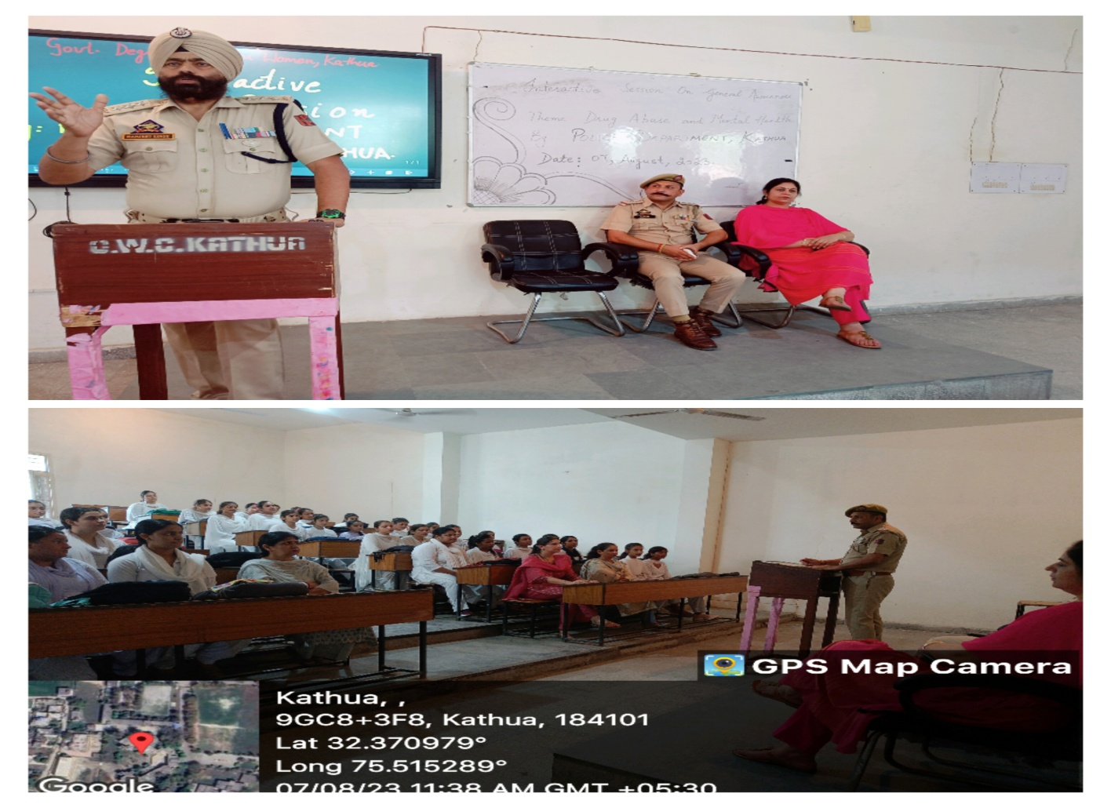

Sd/-
Principal

